**Finding Tweety Bird a New Cage**

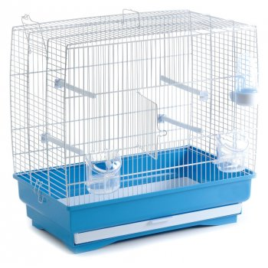

This is a picture of my old cage… it’s too small and not very interesting. I would like something a bigger, more room for me to fly! And maybe something with a little more character… the vintage look could be nice. Or maybe even one that is a little more ornate! Well, just wanted to show what I had beforehand to give you something to compare it to! Remember to keep track of what you find via Coagmento!